**COVID-19 Health Knowledge Graph**

**1 Introduction and Potential Applications**

The COVID-19 Health Knowledge Graph includes kinds of diseases, drugs, symptoms, examinations and designated hospitals about COVID-19.

Potential applications: Epidemiological investigation, QA based on health protection of COVID-19.

**2 Schema**

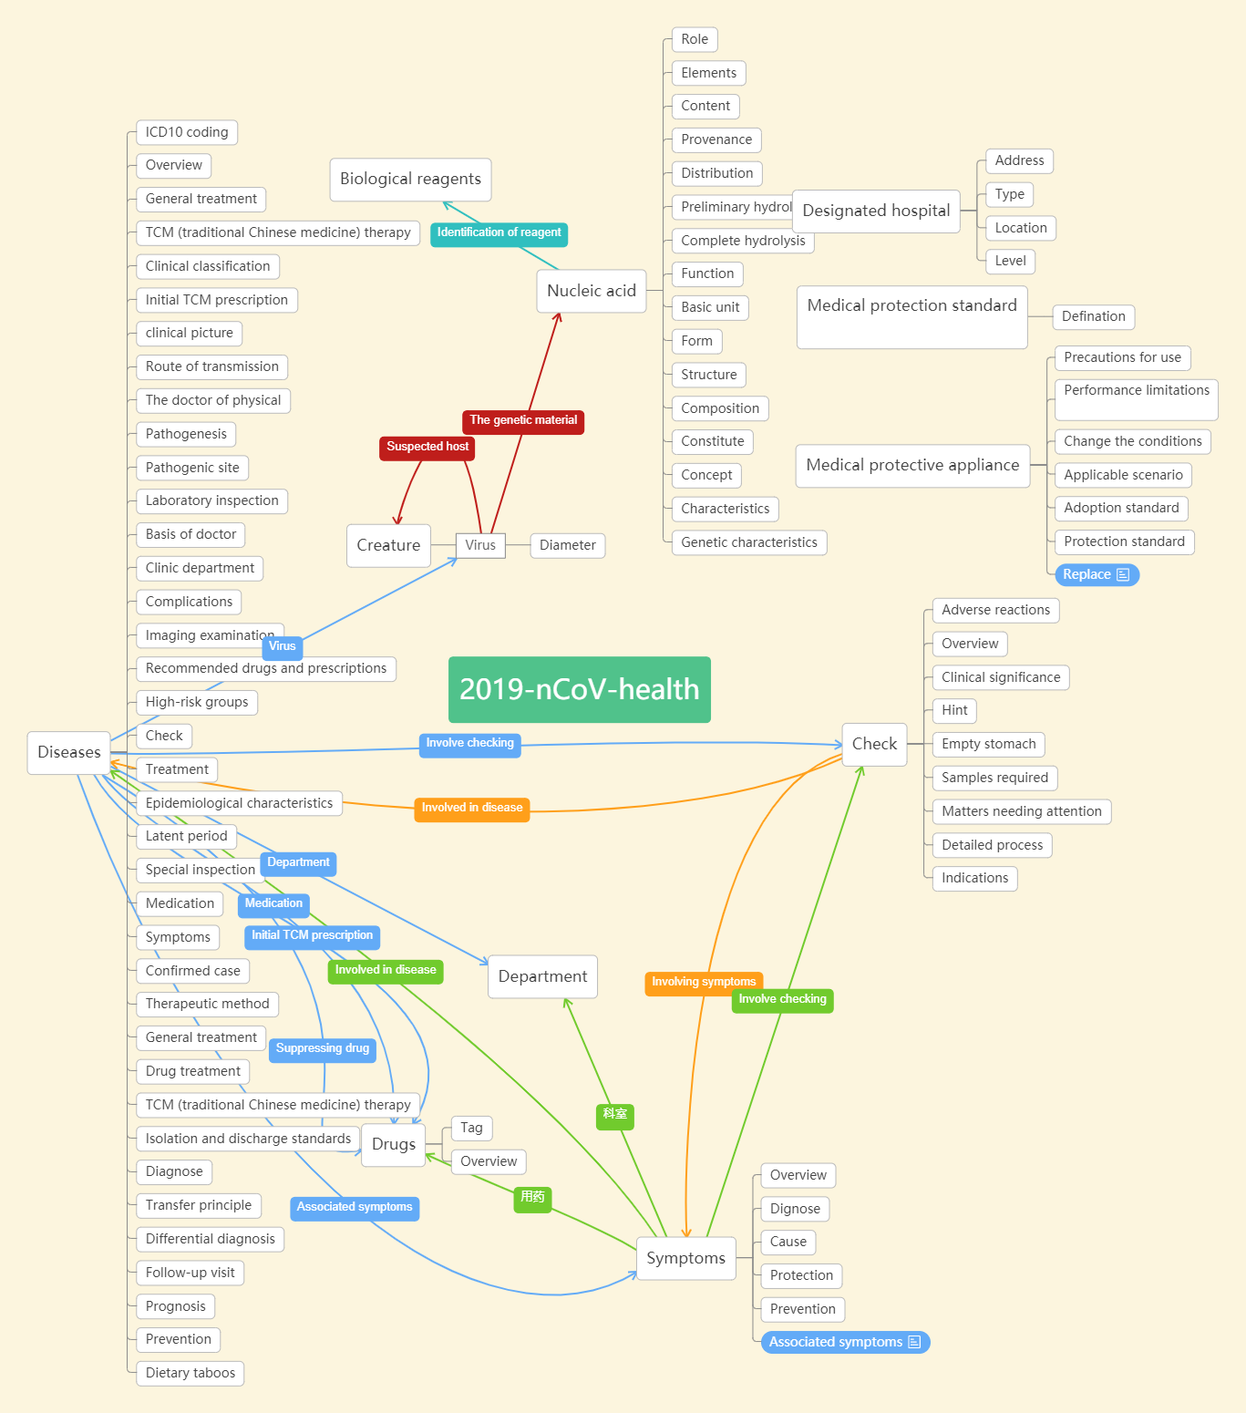

**3 Data**

**Source and Scale**

Source：

《Novel coronavirus pneumonia treatment plan》

Baidu Baike

Beijing More Health Company

Health Commission

Scale:

Concepts：592

Instances：7205

Data properties：89

Object properties：16

Number of triples：51575

**4 Standard**

Namespace：[http://www.openkg.cn/2019-nCoV/health/](http://www.openkg.cn/2019-nCoV/health/" \t "_blank)

Attribute definitions：[http://www.openkg.cn/2019-nCoV/health/property/P+ID](http://www.openkg.cn/2019-nCoV/health/property/P+ID" \t "_blank)（Integer）

Concept definitions：[http://www.openkg.cn/2019-nCoV/](http://www.openkg.cn/2019-nCoV/" \t "_blank) health /class/C+ID（Integer）

Instance definitions：[http://www.openkg.cn/2019-nCoV/](http://www.openkg.cn/2019-nCoV/" \t "_blank) health /resource/R+ID（Integer）

**5 Visual Knowledge Graph Sample**

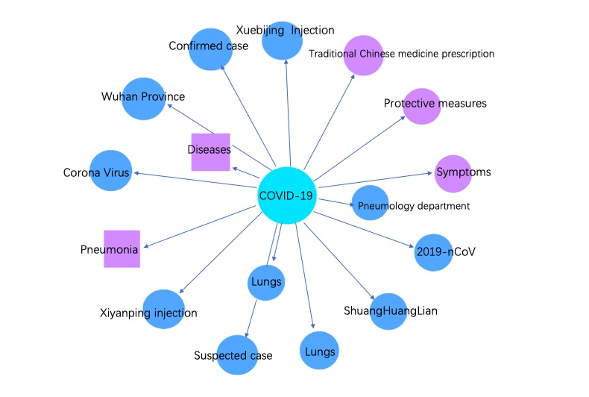

**6** **The Introduction of Author**

Bin Xu      xubin@tsinghua.edu.cn      Tsinghua University Yiming Mao    845285227@qq.com         Tsinghua University Jingya Yan    yanjy16@qq.com          Tsinghua University

Fengling Chu   18310728254@163.com      Tsinghua University Gaochen Wu   wgc2019@mail.tsinghua.edu.cn   Tsinghua University

Meihan Tong   [tongmh17@mails.tsinghua.edu.cn](mailto:tongmh17@mails.tsinghua.edu.cn)  Tsinghua University Jingyi Sun    820567377@qq.com         Tsinghua University

Ziming Li    liziming5353@126.com        Tsinghua University Qiuyang Chen    autumnchenqy@aliyun.com    Tsinghua University

Kaiman Li    201822210009@mail.bnu.edu.cn   Tsinghua University

Xiaofei Zheng    13718825535@126.com      Tsinghua University Bangchang Liu    [liubangchang@miao.cn](mailto:liubangchang@miao.cn)   More Health Company

Dejie Chang    [changdejie@miao.cn](mailto:changdejie@miao.cn) More Health Company

Guangqing yan    yanguangqing@miao.cn     More Health Company

Ke ji      [jike@miao.cn](mailto:jike@miao.cn)           More Health Company