**3.新冠临床图谱**

**3. the Medical KG**

**3.1 简介以及潜在应用**

**3.1 Introduction and Potential Applications**

从诊疗规范(流行病学+症状+实验室指标+治疗)；研究进展(测序、药物开发、疫苗)；发病统计(丁香园)出发， 研究进展与科研关联，从目前已有的规范文件入手出发。

图谱以 2019 冠状病毒病（COVID-19）为核心延展至病毒、治疗方案、症状、方剂等各类概念，形成新冠临床知识图谱，可基于图谱进行知识问答。

Starting from the standard of diagnosis and treatment (epidemiology, symptoms,laboratory indicators and treatment), research progress (sequencing, drug development, vaccines), incidence statistics to research progress related to scientific research, the medical KG is developed by extracting knowledge from the existing standard documents and Web. Base on the medical KG, intelligent question-answering system can be constructed.

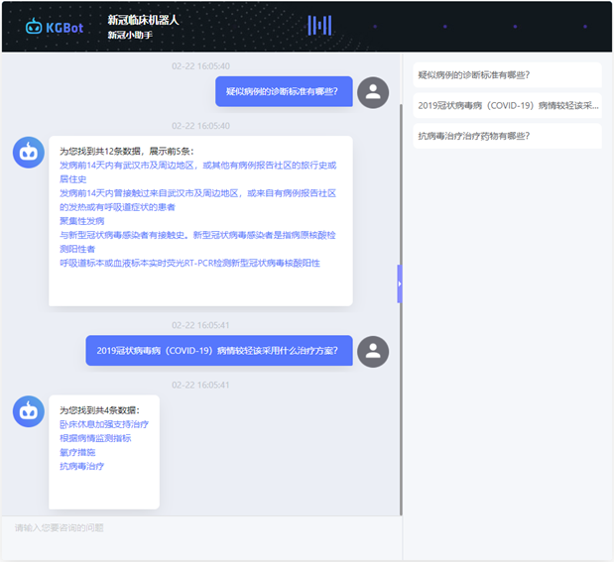

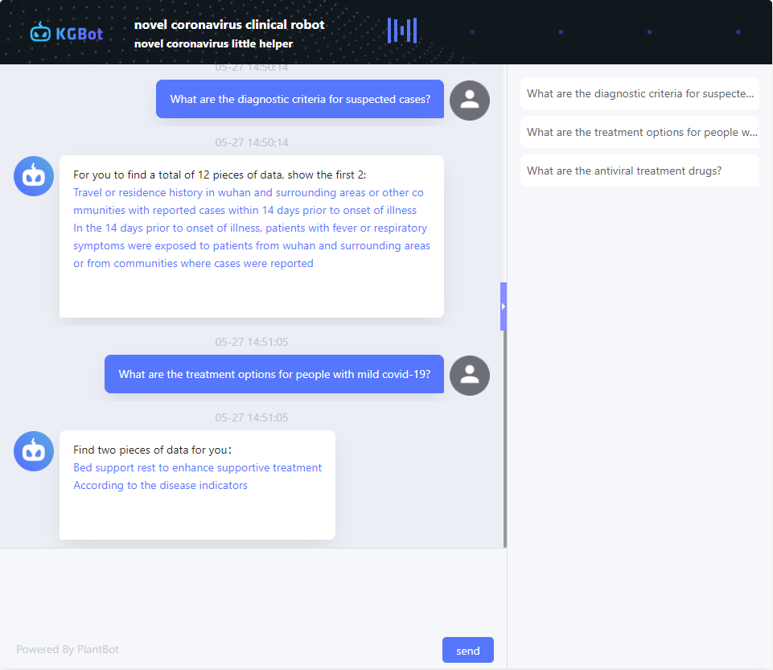

* 示例问题

问：疑似病例的诊断标准有哪些？

答：发病前 14 天内有武汉市及周边地区，或其他有病例报告社区的旅行史或居住史；发病前 14 天内曾接触过来自武汉市及周边地区，或来自有病例报告社区的发热或有呼吸道症状的患者；聚集性发病；与新型冠状病毒感染者有接触史。新型冠状病毒感染者是指病原核酸检测阳性者

问：2019 冠状病毒病（COVID-19）病情较轻该采用什么治疗方案？

答：卧床休息加强支持治疗、根据病情监测指标、氧疗措施、抗病毒治疗

问：抗病毒治疗治疗药物有哪些？

答：α-干扰素、灭菌注射用水、洛匹那韦、利托那韦、利巴韦林

• Example questions

Q: What are the diagnostic criteria for suspected cases?

Answer: Travel history or residence history of Wuhan city and surrounding areas, or other communities with case reports within 14 days before onset; contact with fever or Patients with respiratory symptoms; aggregate disease; history of contact with novel coronavirus infection. Novel coronavirus infection refers to those with positive detection of pathogenic nucleic acid

Q: What are the treatment options for people with mild covid-19?

Answer: bed rest to strengthen supportive treatment, monitoring indicators according to the condition, oxygen therapy measures, antiviral treatment

Q: What are the antiviral treatment drugs?

Answer: α-interferon, sterile water for injection, lopinavir, ritonavir, ribavirin

**3.2 数据 schema**

**3.2 Schema**

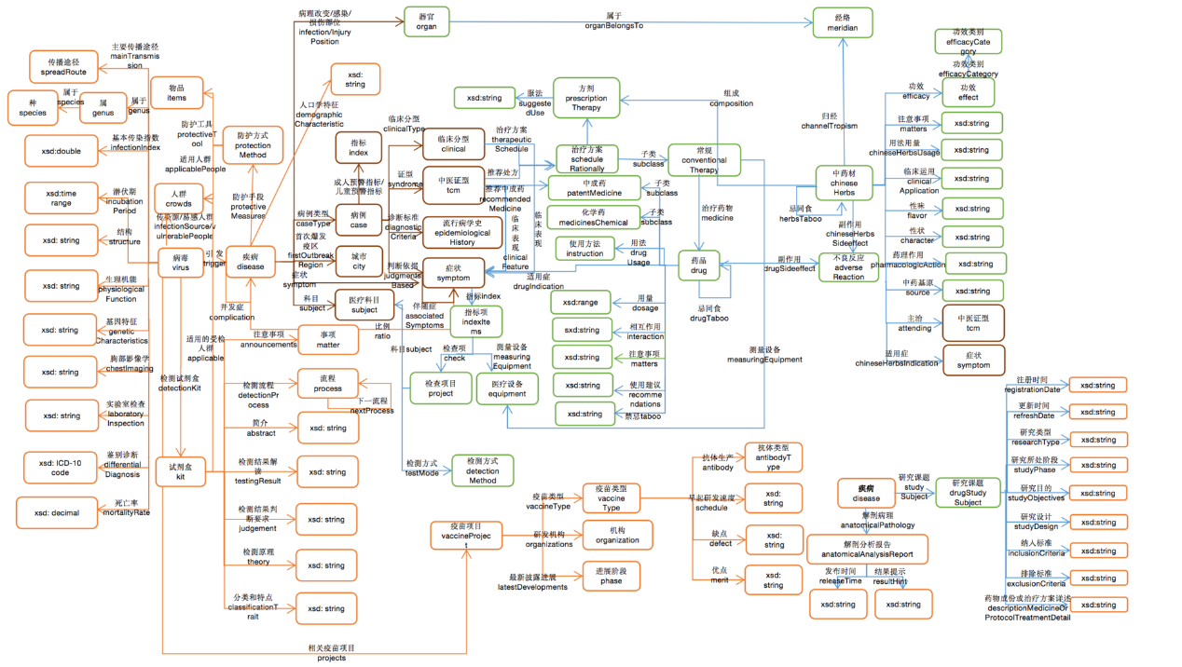

* Schema 简要说明及示例

详见《临床 Schema 简要说明及示例》

• Schema brief description and examples

See "Medical Schema Brief Description and Examples" for details

**3.3 数据来源与规模**

**3.3 Data Source and Size**

数据来源：

《新型冠状病毒感染的肺炎诊疗方案》

wiki 百科

<http://www.tcmkb.cn/> 中医药知识服务平台

<https://db.yaozh.com/fenleimulu?from=www&position=index_hotdb> 医疗器械分类目录

<https://github.com/liuhuanyong/QASystemOnMedicalKG>

数据规模：

概念：54 个

实例：1035 个

数值属性：1258 个

对象属性：1685 个

Data Source :

- “COVID-19 treatment program”

- Wikipedia

- TCM knowledge service platform

- classification catalogue of medical devices

Data Size :

|  |  |  |  |
| --- | --- | --- | --- |
| Concepts | Instances | Numerical Properties | Object Attributes |
| 54 | 1,035 | 1,258 | 1,685 |

**3.4 图谱规范**

**3.4 Naming Convention**

命名空间：http://www.openkg.cn/COVID-19/medical/

属性定义：http://www.openkg.cn/COVID-19/medical/{概念标识符}/property#{属性名称}

概念定义：http://www.openkg.cn/COVID-19/medical/class/{概念标识符}

实体定义：http://www.openkg.cn/COVID-19/medical/resource/{概念标识符}

实体及概念标识符采用 Base64 编码，属性名称采用 URL 风格编码

Namespace：http://www.openkg.cn/COVID-19/medical/

Property definition：http://www.openkg.cn/COVID-19/medical/{sourceName}/property#{propertyName}

Source definition：http://www.openkg.cn/COVID-19/medical/class/{sourceName}

Resource definition：<http://www.openkg.cn/COVID-19/medical/resource/{sourceName}>

**3.5 作者介绍**

**3.5 About the Author**

蔡嘉辉：caijiahui@plantdata.ai 海乂知信息科技(南京)有限公司

杜会芳：duhuifang@memect.co 北京文因互联科技有限公司

冯莉：fengli@plantdata.ai 海乂知信息科技(南京)有限公司

Jiahui Cai: caijiahui@plantdata.ai PlantData

Huifang Du: duhuifang@memect.co memect China

Li Feng: fengli@plantdata.ai PlantData

**3.6 可视化样例**

**3.6 Visualization**

